3.6.3.6 Tessellation
# Source: AI Source: Provided by: [Data Path: Persons Table -> ID Column: 1, Name_En Column: Motasem Essam] -> From: [ChatGPT] on [7/25/2026]
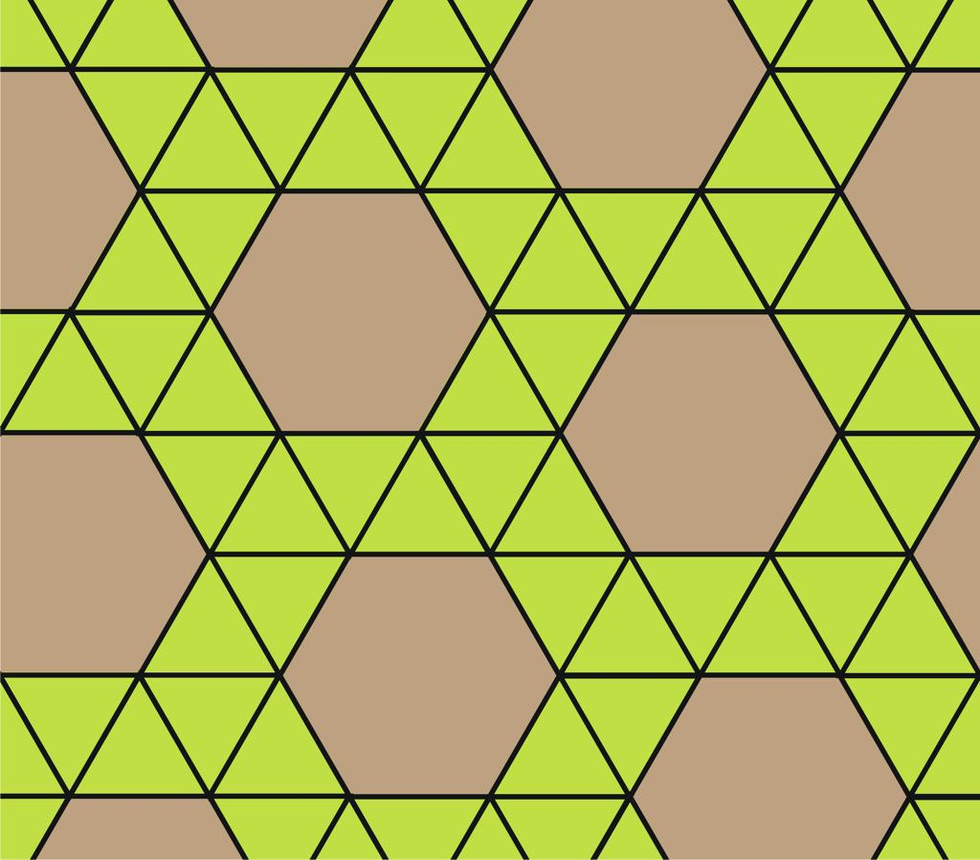
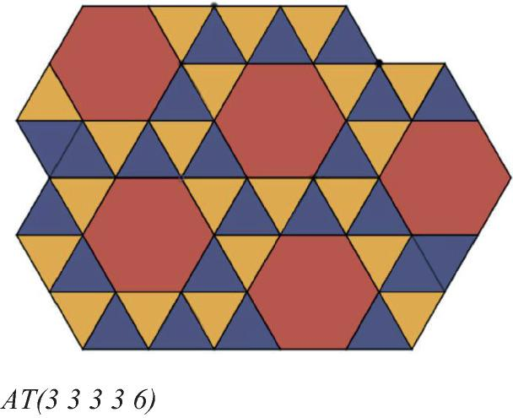
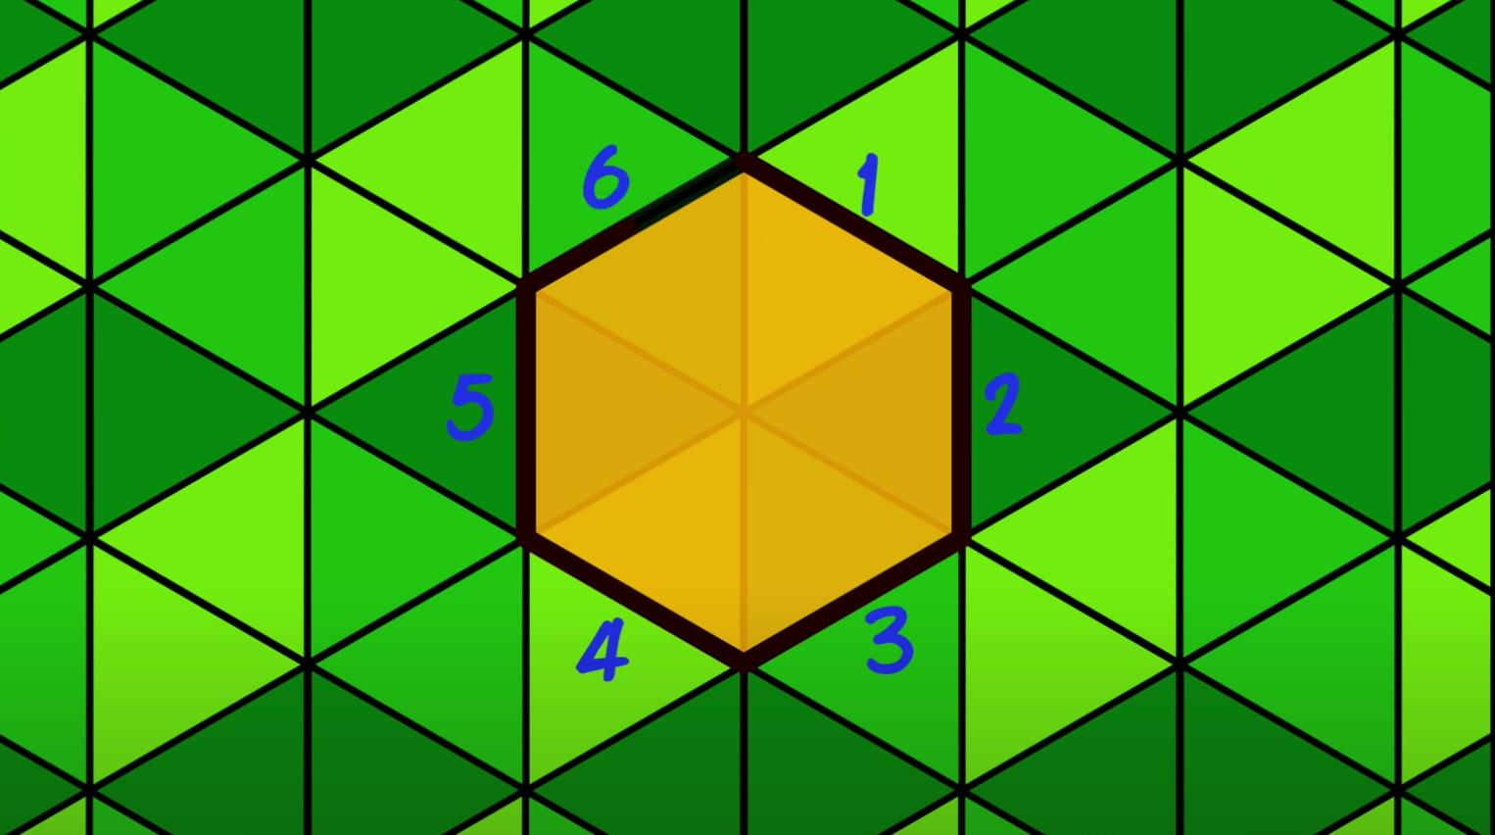
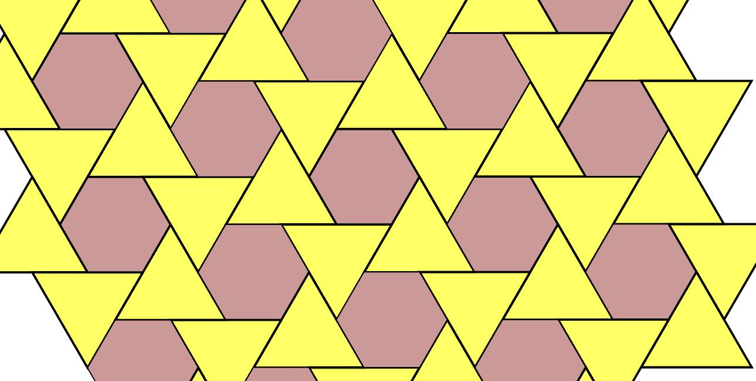
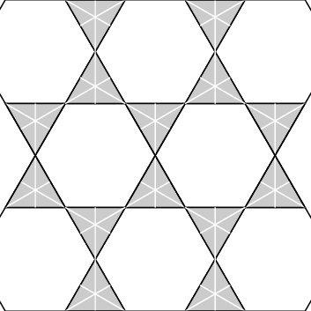

Definition
# Source: AI Source: Provided by: [Data Path: Persons Table -> ID Column: 1, Name_En Column: Motasem Essam] -> From: [ChatGPT] on [7/25/2026]
The 3.6.3.6 tessellation is a semi-regular (Archimedean) tessellation of the Euclidean plane composed of equilateral triangles and regular hexagons.
Its vertex configuration is:
$$\boxed{3.6.3.6}$$
This means that, around every vertex, the polygons occur in the cyclic order:
Triangle → Hexagon → Triangle → Hexagon

Basic Structure
# Source: AI Source: Provided by: [Data Path: Persons Table -> ID Column: 1, Name_En Column: Motasem Essam] -> From: [ChatGPT] on [7/25/2026]
The tessellation contains only:
- 🔺 Equilateral triangles
- ⬡ Regular hexagons
The hexagons form the larger repeating framework, while the triangles occupy the spaces between neighboring hexagons. (tessell.art)
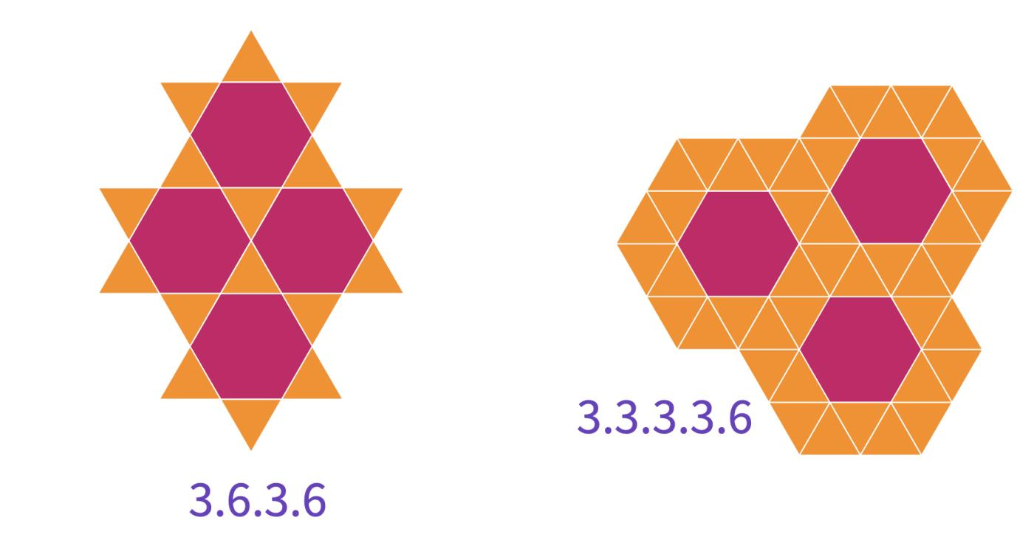
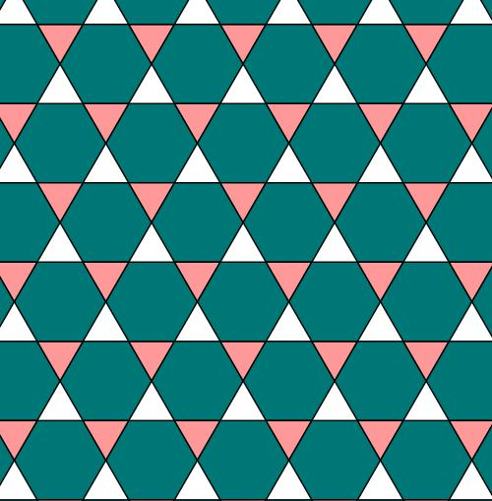
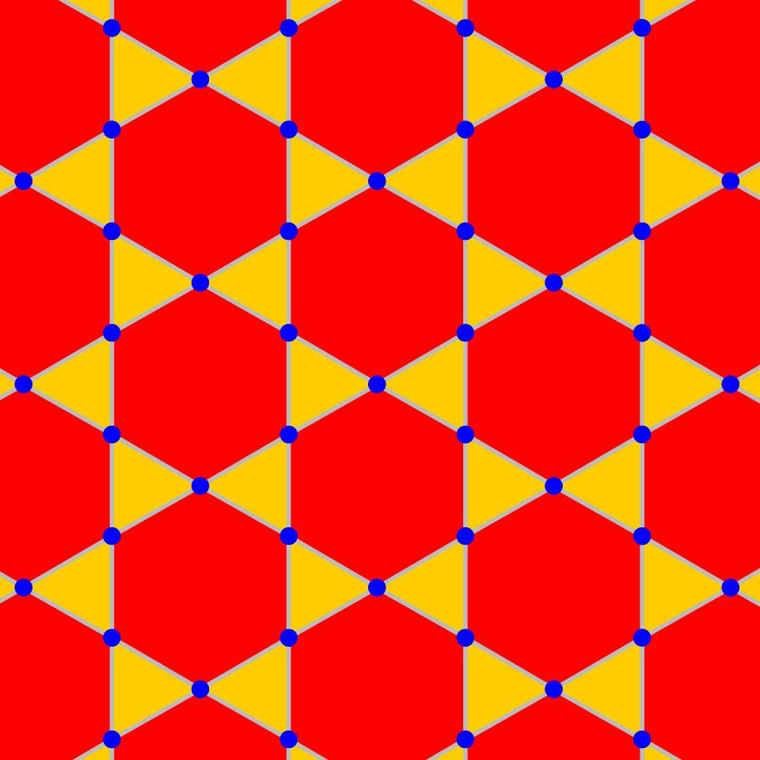

Classification
# Source: AI Source: Provided by: [Data Path: Persons Table -> ID Column: 1, Name_En Column: Motasem Essam] -> From: [ChatGPT] on [7/25/2026]
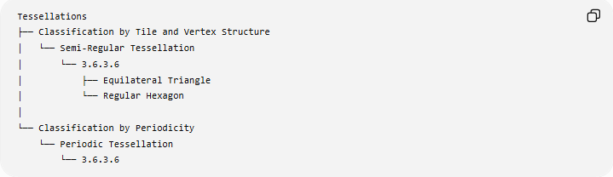
Tessellations
├── Classification by Tile and Vertex Structure
│ └── Semi-Regular Tessellation
│ └── 3.6.3.6
│ ├── Equilateral Triangle
│ └── Regular Hexagon
│
└── Classification by Periodicity
└── Periodic Tessellation
└── 3.6.3.6
Therefore:
$$\boxed{\text{3.6.3.6 is Semi-Regular and Periodic}}$$

Fundamental Elements
# Source: AI Source: Provided by: [Data Path: Persons Table -> ID Column: 1, Name_En Column: Motasem Essam] -> From: [ChatGPT] on [7/25/2026]
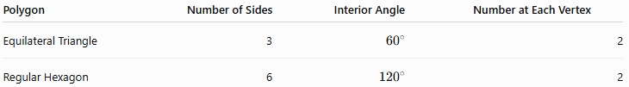
Polygon | Number of Sides | Interior Angle | Number at Each Vertex
Equilateral Triangle | 3 | $${60}^{∘}$$ | 2
Regular Hexagon | 6 | $${120}^{∘}$$ | 2
Thus, four polygons meet at every vertex:
$$\boxed{2\text{ triangles}+2\text{ hexagons}}$$

Vertex Angle Verification
# Source: AI Source: Provided by: [Data Path: Persons Table -> ID Column: 1, Name_En Column: Motasem Essam] -> From: [ChatGPT] on [7/25/2026]
The angles around each vertex are:
$${60}^{∘}+{120}^{∘}+{60}^{∘}+{120}^{∘}$$
Therefore:
$$\boxed{{60}^{∘}+{120}^{∘}+{60}^{∘}+{120}^{∘}={360}^{∘}}$$
The polygons completely fill the plane around every vertex.

Vertex Configuration
# Source: AI Source: Provided by: [Data Path: Persons Table -> ID Column: 1, Name_En Column: Motasem Essam] -> From: [ChatGPT] on [7/25/2026]
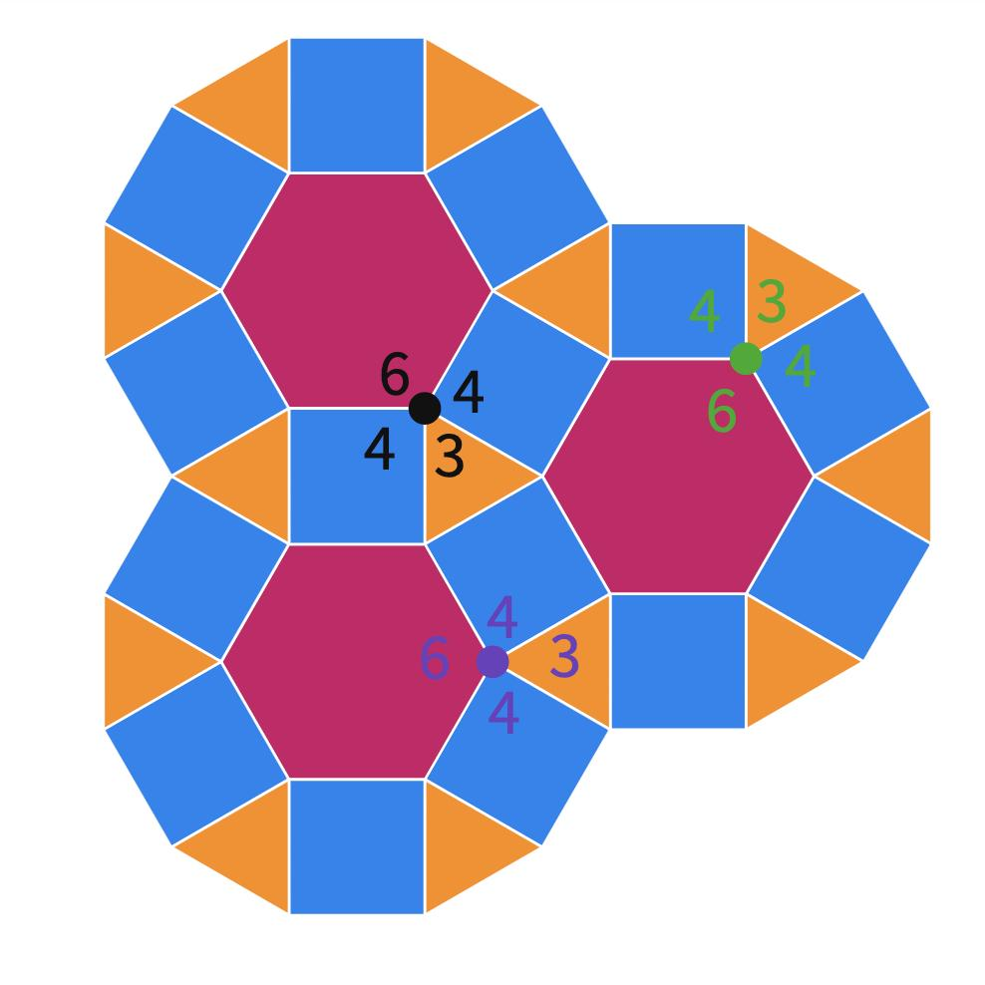
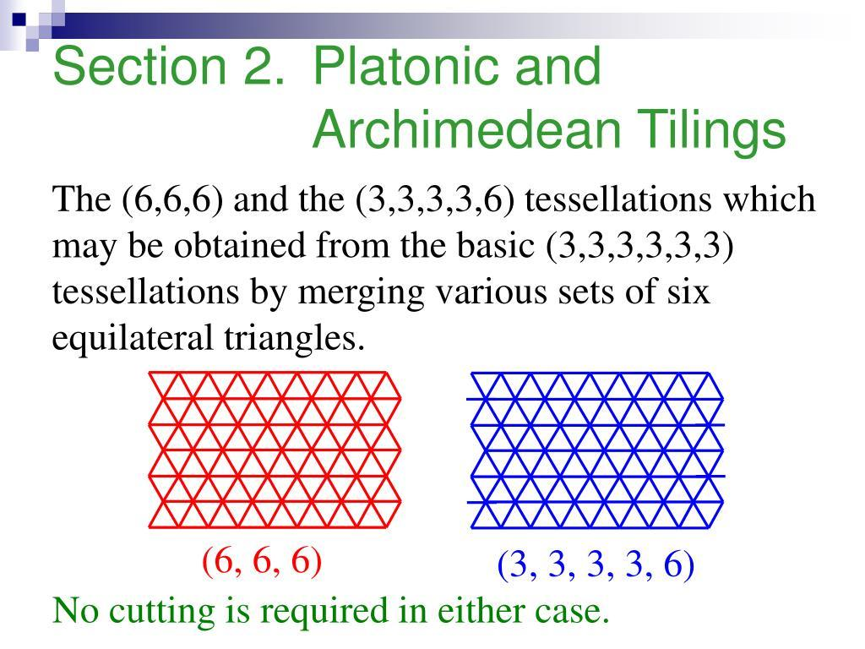
The notation
$$\boxed{3.6.3.6}$$
describes the number of sides of the polygons encountered in cyclic order around a vertex:
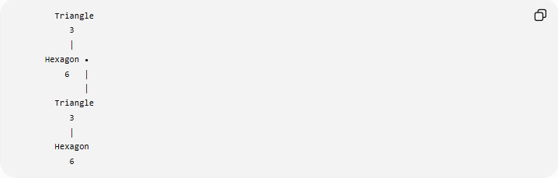
Triangle
3
│
Hexagon •
6 │
│
Triangle
3
│
Hexagon
6
The essential sequence is:
$$\boxed{3→6→3→6}$$
The triangle and hexagon alternate around every vertex.

Why It Is Semi-Regular
# Source: AI Source: Provided by: [Data Path: Persons Table -> ID Column: 1, Name_En Column: Motasem Essam] -> From: [ChatGPT] on [7/25/2026]
The $3.6.3.6$tessellation satisfies the defining conditions of a semi-regular tessellation:
- All tiles are regular polygons.
- Two different polygon types are used.
- The same vertex configuration occurs at every vertex.
- The polygons meet edge-to-edge.
- There are no gaps or overlaps.
Therefore:
$$\boxed{\text{3.6.3.6 is a Semi-Regular Tessellation}}$$

Why It Is Not Regular
# Source: AI Source: Provided by: [Data Path: Persons Table -> ID Column: 1, Name_En Column: Motasem Essam] -> From: [ChatGPT] on [7/25/2026]
A regular tessellation contains only one type of regular polygon.
The $3.6.3.6$tessellation contains:
- Equilateral triangles
- Regular hexagons
Therefore:
$$\boxed{\text{3.6.3.6 is not a Regular Tessellation}}$$

Periodicity
# Source: AI Source: Provided by: [Data Path: Persons Table -> ID Column: 1, Name_En Column: Motasem Essam] -> From: [ChatGPT] on [7/25/2026]
The entire pattern repeats through translations, so it has translational symmetry.
Therefore:
$$\boxed{\text{3.6.3.6 is Periodic}}$$
Its complete classification is:
$$\boxed{\text{Semi-Regular + Periodic}}$$

Mathematical Representation
# Source: AI Source: Provided by: [Data Path: Persons Table -> ID Column: 1, Name_En Column: Motasem Essam] -> From: [ChatGPT] on [7/25/2026]
For a regular $n$-gon:
$$θ_{n}=\frac{\left(n-2\right){180}^{∘}}{n}$$
For an equilateral triangle:
$$θ_{3}={60}^{∘}$$
For a regular hexagon:
$$θ_{6}={120}^{∘}$$
Therefore, at each vertex:
$$θ_{3}+θ_{6}+θ_{3}+θ_{6}={360}^{∘} \\ \boxed{{60}^{∘}+{120}^{∘}+{60}^{∘}+{120}^{∘}={360}^{∘}}$$

Equivalent Compact Notation
# Source: AI Source: Provided by: [Data Path: Persons Table -> ID Column: 1, Name_En Column: Motasem Essam] -> From: [ChatGPT] on [7/25/2026]
The configuration can also be written as:
$$\boxed{3^{2}{.6}^{2}}$$
This means:
- $3^{2}$→ two triangles
- $6^{2}$→ two hexagons
The expanded notation $3.6.3.6$additionally shows their alternating cyclic order.

Comparison with 3.3.3.3.6
# Source: AI Source: Provided by: [Data Path: Persons Table -> ID Column: 1, Name_En Column: Motasem Essam] -> From: [ChatGPT] on [7/25/2026]
Both configurations contain triangles and hexagons, but they are different.
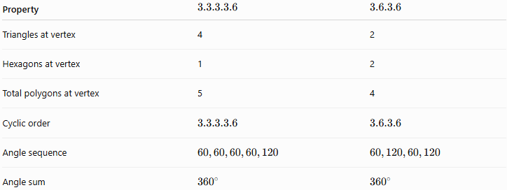
Property | $$3.3.3.3.6$$ | $$3.6.3.6$$
Triangles at vertex | 4 | 2
Hexagons at vertex | 1 | 2
Total polygons at vertex | 5 | 4
Cyclic order | $$3.3.3.3.6$$ | $$3.6.3.6$$
Angle sequence | $$60,60,60,60,120$$ | $$60,120,60,120$$
Angle sum | $${360}^{∘}$$ | $${360}^{∘}$$
Thus:
$$\boxed{3.3.3.3.6≠3.6.3.6}$$

Comparison with 3.4.6.4
# Source: AI Source: Provided by: [Data Path: Persons Table -> ID Column: 1, Name_En Column: Motasem Essam] -> From: [ChatGPT] on [7/25/2026]
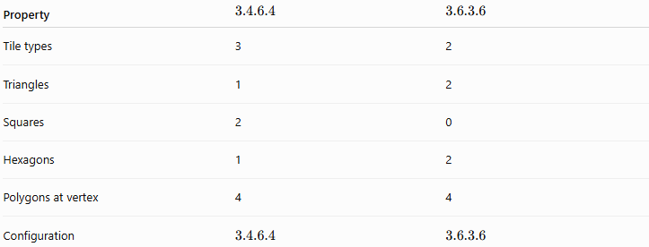
Property | $$3.4.6.4$$ | $$3.6.3.6$$
Tile types | 3 | 2
Triangles | 1 | 2
Squares | 2 | 0
Hexagons | 1 | 2
Polygons at vertex | 4 | 4
Configuration | $$3.4.6.4$$ | $$3.6.3.6$$
The $3.6.3.6$tessellation has no squares; it alternates triangles and hexagons.

Key Properties
# Source: AI Source: Provided by: [Data Path: Persons Table -> ID Column: 1, Name_En Column: Motasem Essam] -> From: [ChatGPT] on [7/25/2026]
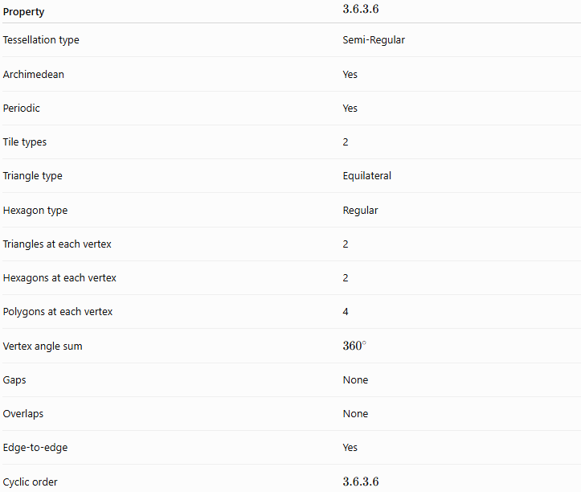
Property | $$3.6.3.6$$
Tessellation type | Semi-Regular
Archimedean | Yes
Periodic | Yes
Tile types | 2
Triangle type | Equilateral
Hexagon type | Regular
Triangles at each vertex | 2
Hexagons at each vertex | 2
Polygons at each vertex | 4
Vertex angle sum | $${360}^{∘}$$
Gaps | None
Overlaps | None
Edge-to-edge | Yes
Cyclic order | $$3.6.3.6$$

Relationship to the Eight Semi-Regular Tessellations
# Source: AI Source: Provided by: [Data Path: Persons Table -> ID Column: 1, Name_En Column: Motasem Essam] -> From: [ChatGPT] on [7/25/2026]
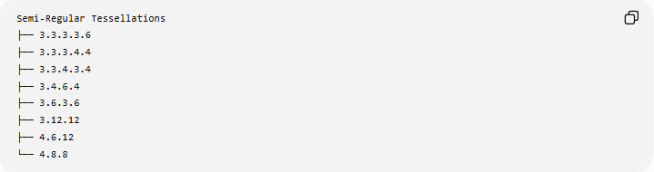
Semi-Regular Tessellations
├── 3.3.3.3.6
├── 3.3.3.4.4
├── 3.3.4.3.4
├── 3.4.6.4
├── 3.6.3.6
├── 3.12.12
├── 4.6.12
└── 4.8.8
The $3.6.3.6$configuration is therefore one of the eight Archimedean tessellations of the Euclidean plane.

Key Points
# Source: AI Source: Provided by: [Data Path: Persons Table -> ID Column: 1, Name_En Column: Motasem Essam] -> From: [ChatGPT] on [7/25/2026]
- $3.6.3.6$is a semi-regular tessellation.
- It is also periodic.
- It uses only:
  - Equilateral triangles
  - Regular hexagons
- Four polygons meet at each vertex.
- There are two triangles and two hexagons at each vertex.
- The polygons alternate:
$$\boxed{3→6→3→6}$$
- The vertex angles sum to:
$$\boxed{{360}^{∘}}$$
- Its compact notation is:
$$\boxed{3^{2}{.6}^{2}}$$

Conclusion
# Source: AI Source: Provided by: [Data Path: Persons Table -> ID Column: 1, Name_En Column: Motasem Essam] -> From: [ChatGPT] on [7/25/2026]
The 3.6.3.6 tessellation is a semi-regular, periodic tessellation formed by equilateral triangles and regular hexagons. At every vertex, two triangles and two hexagons alternate in the cyclic configuration
$$\boxed{3.6.3.6}$$
and their angles satisfy
$$\boxed{{60}^{∘}+{120}^{∘}+{60}^{∘}+{120}^{∘}={360}^{∘}}$$
allowing the entire Euclidean plane to be covered without gaps or overlaps.

